**VISVESVARAYA TECHNOLOGICAL UNIVERSITY**

**“Jnana Sangama”, Belgaum-590018**

**INTERNSHIP REPORT**

**ON**

**“A Model for Predicting Demand-Supply Information of**

**TOP Crops”**

***Submitted in partial fulfilment for the award of degree(18CSI85)***

**BACHELOR OF ENGINEERING**

**IN**

**COMPUTER SCIENCE AND ENGINEERING**

***Submitted by:***

**NAME : LATHARANI**

**USN : 1DB20CS405**



Conducted at

**COMPSOFT TECHNOLOGIES**



**Department of Computer Science and Engineering**

**DON BOSCO INSTITUTE OF TECHNOLOGY**

# Kumbalagodu, Mysore Road, Bengaluru - 560 074

**DON BOSCO INSTITUTE OF TECHNOLOGY**

**Kumbalagodu, Mysore Road, Bengaluru - 560 074**



**Department of Computer Science and Engineering**

**CERTIFICATE**

This is to certify that the Internship titled **“A Model for Predicting Demand-Supply Information of TOP Crops”** carried out by **Latharani (1DB20CS405) ,** a bonafide student at Don Bosco Institute of Technology, in partial fulfillment for the award of **Bachelor of Engineering**, in **Computer Science and Engineering** under Visvesvaraya Technological University, Belagavi, during the year 2022-2023. It is certified that all corrections/suggestions indicated have been incorporated in the report.

The project report has been approved as it satisfies the academic requirements in respect of Internship prescribed for the course Internship / Professional Practice (18CSI85)

**Signature of Guide** **Signature of HOD Signature of Principal**

**………………….. ………………….. ……………………..**

**External Viva:**

Name of the Examiner: Signature with Date:

1) …………………………

2)………………………….

**DON BOSCO INSTITUTE OF TECHNOLOGY**

**Kumbalagodu, Mysore Road, Bengaluru - 560 074**



**Department of Computer Science and Engineering**

**DECLARATION**

I, **Latharani**, final year student B.E, Department of Computer Science and Engineering, Don Bosco Institute of Technology, Kumbalagodu, Bengaluru, declare that the Internship has been successfully completed, in **COMPSOFT TECHNOLOGIES**. This report is submitted in partial fulfillment of the requirements for award of Bachelor Degree in Computer Science and Engineering, during the academic year 2022-2023.

Date : 25/09/2022 :

Place : Bengaluru

USN : 1DB20CS405

NAME : Latharani

**OFFER LETTER**

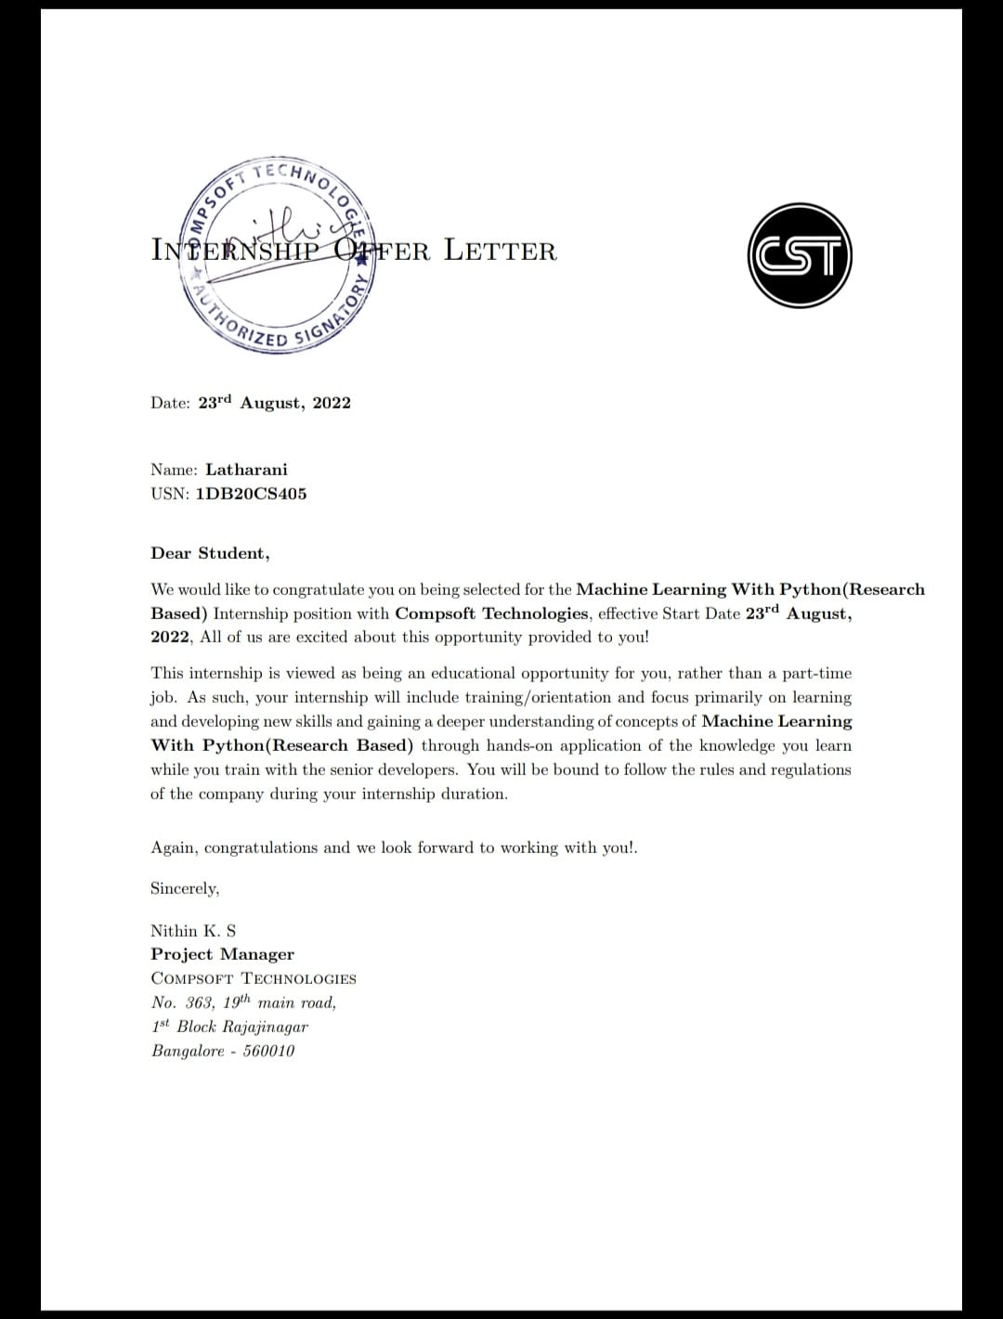

**ACKNOWLEDGEMENT**

This Internship is a result of accumulated guidance, direction and support of several important persons. We take this opportunity to express our gratitude to all who have helped us to complete the Internship.

We express our sincere thanks to our Principal, for providing us adequate facilities to undertake this Internship.

We would like to thank our Head of Department, Dr. K. B. Shivakumar, for providing us an opportunity to carry out Internship and for his valuable guidance and support.

We express our deep and profound gratitude to our guide, Prof. Vishesh J ,Asst. Prof, Dept of CSE, for Hi keen interest and encouragement at every step in completing the Internship.

We would like to thank all the faculty members of our department for the support extended during the course of Internship.

We would like to thank the non-teaching members of our dept, for helping us during the Internship.

Last but not the least, we would like to thank our parents and friends without whose constant help, the completion of Internship would have not been possible.

**NAME : LATHARANI**

**USN : 1DB19CS405**

**ABSTRACT**

India is majorly an agriculture-based economy. Around 42% of the people depend on agriculture for their livelihood. The economic upliftment of farmers happens when there is a seamless transfer of agricultural produce from producers to the consumers. It is evident that there is a huge gap between demand and supply of various crops, due to which both farmers and consumers are facing problems. At present, in India there is no system in place to efficiently manage this demand and supply issue. The potential of present-day technologies like data analytics, machine learning can be exploited to overcome these issues. The available data about the demand, supply, price variation of the crops and other factors affecting the supply chain of agricultural produce

can be used to analyze and come up with a model to predict and forecast market variations of agricultural crops. The proposed work intends to analyze the various authentic data available for TOP (Tomato, Potato and Onion) crops and design a supply-demand prediction model to forecast the market fluctuations as an advisory measure.

**TABLE OF CONTENTS**

|  |  |  |
| --- | --- | --- |
| **Sl no** | **Description** | **Page no** |
| 1 | Company Profile | 2 |
| 2 | About the Company | 4-7 |
| [3](https://1.bp.blogspot.com/-dODuK8N5h1Q/Wlnyb3V9HFI/AAAAAAAACL4/WxQtCJ1pM5wccDABg4wIrTBUB0vlikXQQCLcBGAs/s1600/poly1.jpg) | Introduction | 9 |
| [4](https://1.bp.blogspot.com/-dODuK8N5h1Q/Wlnyb3V9HFI/AAAAAAAACL4/WxQtCJ1pM5wccDABg4wIrTBUB0vlikXQQCLcBGAs/s1600/poly1.jpg) | System Analysis | 11 |
| [5](https://1.bp.blogspot.com/-dODuK8N5h1Q/Wlnyb3V9HFI/AAAAAAAACL4/WxQtCJ1pM5wccDABg4wIrTBUB0vlikXQQCLcBGAs/s1600/poly1.jpg) | Requirement Analysis | 13 |
| 6 | Design [Analysis](https://4.bp.blogspot.com/-IOOxgPaXMVc/Wlj3LWvcnjI/AAAAAAAACKE/UeTFYvAxDmUDel5UBjdifeWaApB3-dXVgCLcBGAs/s1600/img1.jpg) | 15 |
| 7 | [Implementation](https://4.bp.blogspot.com/-IOOxgPaXMVc/Wlj3LWvcnjI/AAAAAAAACKE/UeTFYvAxDmUDel5UBjdifeWaApB3-dXVgCLcBGAs/s1600/img1.jpg) | 17-19 |
| 8 | Snapshots | 21-22 |
| 9 | Conclusion | 24 |
| 10 | References | 26 |

[**CHAPTER**](https://1.bp.blogspot.com/-dODuK8N5h1Q/Wlnyb3V9HFI/AAAAAAAACL4/WxQtCJ1pM5wccDABg4wIrTBUB0vlikXQQCLcBGAs/s1600/poly1.jpg) **1** **COMPANY PROFILE**

1. **COMPANY PROFILE**

**A Brief History of Compsoft Technologies**

Compsoft Technologies, was incorporated with a goal ”To provide high quality and optimal Technological Solutions to business requirements of our clients”. Every business is a different and has a unique business model and so are the technological requirements. They understand this and hence the solutions provided to these requirements are different as well. They focus on clients requirements and provide them with tailor made technological solutions. They also understand that Reach of their Product to its targeted market or the automation of the existing process into e-client and simple process are the key features that our clients desire from Technological Solution they are looking for and these are the features that we focus on while designing the solutions for their clients.

Sarvamoola Software Services. is a Technology Organization providing solutions for all web design and development, MYSQL, PYTHON Programming, HTML, CSS, ASP.NET and LINQ. Meeting the ever increasing automation requirements, Sarvamoola Software Services. specialize in ERP, Connectivity, SEO Services, Conference Management, effective web promotion and tailor-made software products, designing solutions best suiting clients’ requirements.

Compsoft Technologies, strive to be the front runner in creativity and innovation in software development through their well-researched expertise and establish it as an out of the box software development company in Bangalore, India. As a software development company, they translate this software development expertise into value for their customers through their professional solutions.

They understand that the best desired output can be achieved only by understanding the clients demand better. Compsoft Technologies work with their clients and help them to define their exact solution requirement. Sometimes even they wonder that they have completely redefined their solution or new application requirement during the brainstorming session, and here they position themselves as an IT solutions consulting group comprising of high caliber consultants.

They believe that Technology when used properly can help any business to scale and achieve new heights of success. It helps Improve its efficiency, profitability, reliability; to put it in one sentence”. Technology helps you to Delight your Customers” and that is what they want to achieve.

# [CHAPTER](https://1.bp.blogspot.com/-dODuK8N5h1Q/Wlnyb3V9HFI/AAAAAAAACL4/WxQtCJ1pM5wccDABg4wIrTBUB0vlikXQQCLcBGAs/s1600/poly1.jpg) 2 ABOUT THE COMPANY

1. **ABOUT THE COMPANY**



Compsoft Technologies is a Technology Organization providing solutions for all web design and development, MYSQL, PYTHON Programming, HTML, CSS, ASP.NET and LINQ. Meeting the ever increasing automation requirements, Compsoft Technologies specialize in ERP, Connectivity, SEO Services, Conference Management, effective web promotion and tailor-made software products, designing solutions best suiting clients requirements. The organization where they have a right mix of professionals as a stakeholders to help us serve our clients with best of our capability and with at par industry standards. They have young, enthusiastic, passionate and creative Professionals to develop technological innovations in the field of Mobile technologies, Web applications as well as Business and Enterprise solution. Motto of our organization is to “Collaborate with our clients to provide them with best Technological solution hence creating Good Present and Better Future for our client which will bring a cascading a positive effect in their business shape as well”. Providing a Complete suite of technical solutions is not just our tag line, it is Our Vision for Our Clients and for Us, We strive hard to achieve it.

**Products of Compsoft Technologies**

**Android Apps**

It is the process by which new applications are created for devices running the Android operating system. Applications are usually developed in Java (and/or Kotlin; or other such option) programming language using the Android software development kit (SDK), but other development environments are also available, some such as Kotlin support the exact same Android APIs (and bytecode), while others such as Go have restricted API access.

The Android software development kit includes a comprehensive set of development tools. These include a debugger, libraries, a handset emulator based on QEMU, documentation, sample code, and tutorials. Currently supported development platforms include computers running Linux (any modern desktop Linux distribution), Mac OS X 10.5.8 or later, and Windows 7 or later. As of March 2015, the SDK is not available on Android itself, but software development is possible by using specialized Android applications.

**Web Applications**

It is a client–server computer program in which the client (including the user interface and client- side logic) runs in a web browser. Common web applications include web mail, online

retail sales, online auctions, wikis, instant messaging services and many other functions. web applications use web documents written in a standard format such as HTML and JavaScript, which are supported by a variety of web browsers. Web applications can be considered as a specific variant of client–server software where the client software is downloaded to the client machine when visiting the relevant web page, using standard procedures such as HTTP. The Client web software updates may happen each time the web page is visited. During the session, the web browser interprets and displays the pages, and acts as the universal client for any web application. The use of web application frameworks can often reduce the number of errors in a program, both by making the code simpler, and by allowing one team to concentrate on the framework while another focuses on a specified use case. In applications which are exposed to constant hacking attempts on the Internet, security- related problems can be caused by errors in the program.

Frameworks can also promote the use of best practices such as GET after POST. There are some who view a web application as a two-tier architecture. This can be a “smart” client that performs all the work and queries a “dumb” server, or a “dumb” client that relies on a “smart” server. The client would handle the presentation tier, the server would have the database (storage tier), and the business logic (application tier) would be on one of them or on both. While this increases the scalability of the applications and separates the display and the database, it still doesn’t allow for true specialization of layers, so most applications will outgrow this model. An emerging strategy for application software companies is to provide web access to software previously distributed as local applications. Depending on the type of application, it may require the development of an entirely different browser-based interface, or merely adapting an existing application to use different presentation technology. These programs allow the user to pay a monthly or yearly fee for use of a software application without having to install it on a local hard drive. A company which follows this strategy is known as an application service provider (ASP), and ASPs are currently receiving much attention in the software industry.

Security breaches on these kinds of applications are a major concern because it can involve both enterprise information and private customer data. Protecting these assets is an important part of any web application and there are some key operational areas that must be included in the development process. This includes processes for authentication, authorization, asset handling, input, and logging and auditing. Building security into the applications from the beginning can be more effective and less disruptive in the long run.

**Web design**

It encompasses many different skills and disciplines in the production and maintenance of websites. The different areas of web design include web graphic design; interface design; authoring, including standardized code and proprietary software; user experience design; and

search engine optimization. The term web design is normally used to describe the design process relating to the front-end (client side) design of a website including writing mark up. Web design partially overlaps web engineering in the broader scope of web development. Web designers are expected to have an awareness of usability and if their role involves creating markup then they are also expected to be up to date with web accessibility guidelines. Web design partially overlaps web engineering in the broader scope of web development.

**Departments and services offered**

Compsoft Technologies plays an essential role as an institute, the level of education, development of student’s skills is based on their trainers. We at Compsoft Technologies give you the facility of skilled employees so that you do not feel unsecured about the academics. Personality development and academic status are some of those things which lie on mentor’s hands. If you are trained well then you can do well in your future and knowing its importance of Compsoft Technologies always tries to give you the best.

They have a great team of skilled mentors who are always ready to direct their trainees in the best possible way they can and to ensure the skills of mentors we held many skills development programs as well so that each and every mentor can develop their own skills with the demands of the companies so that they can prepare a complete packaged trainee.

**Services provided by Compsoft Technologies**

* Core Java and Advanced Java
* Web services and development
* Dot Net Framework
* Python
* Selenium Testing
* Conference/Event management service
* Academic Project Guidance
* On The Job Training
* Software Training

# [CHAPTER](https://1.bp.blogspot.com/-dODuK8N5h1Q/Wlnyb3V9HFI/AAAAAAAACL4/WxQtCJ1pM5wccDABg4wIrTBUB0vlikXQQCLcBGAs/s1600/poly1.jpg) 3 INTRODUCTION

1. **INTRODUCTION**

**Introduction to ML**

Machine learning (ML) is a branch of artificial intelligence (AI) that enables computers to “self-learn” from training data and improve over time, without being explicitly programmed. Machine learning algorithms are able to detect patterns in data and learn from them, in order to make their own predictions.

Machine learning is an automated process that enables machines to solve problems with little or no human input, and take actions based on past observations.

**Problem Statement**

A model for predicting demand – supply information of top corps using python programming language

# [CHAPTER](https://1.bp.blogspot.com/-dODuK8N5h1Q/Wlnyb3V9HFI/AAAAAAAACL4/WxQtCJ1pM5wccDABg4wIrTBUB0vlikXQQCLcBGAs/s1600/poly1.jpg) 4 SYSTEM ANALYSIS

**4. SYSTEM ANALYSIS**

## Proposed System

## A predictive model for forecasting demand and supply information of TOP crops using python application

## Objective of the System

## Our main objective is to build a predictive model for forecasting demand and supply information through python programming language

## Large datasets are used to build this predictive model

## All the parameters are analysed using linear regression algorithm

## This model is used to predict the demand and supply information which may help the agriculture supply chain in making necessary decisions in minimizing and managing the risk of price fluctuations.

# [CHAPTER](https://1.bp.blogspot.com/-dODuK8N5h1Q/Wlnyb3V9HFI/AAAAAAAACL4/WxQtCJ1pM5wccDABg4wIrTBUB0vlikXQQCLcBGAs/s1600/poly1.jpg) 5 REQUIREMENT ANALYSIS

**5. REQUIREMENT ANALYSIS**

**Hardware Requirement Specification**

* Processor : Intel Core i3
* RAM : 8GB
* Hard disk : 20GB(approx.)

**Software Requirement Specification**

* Operating System : Windows 10
* Language : Python
* IDE : Goggle Collab

# [CHAPTER](https://1.bp.blogspot.com/-dODuK8N5h1Q/Wlnyb3V9HFI/AAAAAAAACL4/WxQtCJ1pM5wccDABg4wIrTBUB0vlikXQQCLcBGAs/s1600/poly1.jpg) 6 DESIGN ANALYSIS

1. **DESIGN & ANALYSIS**

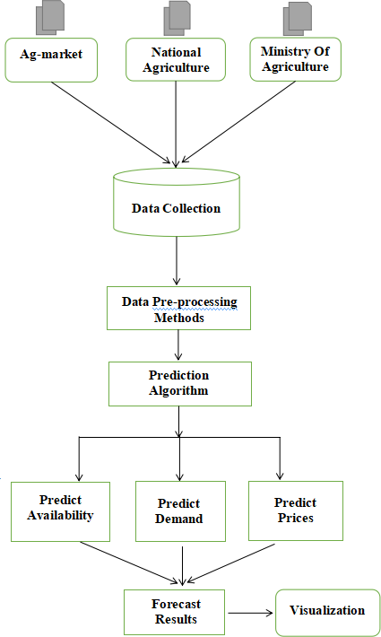

# [CHAPTE](https://1.bp.blogspot.com/-dODuK8N5h1Q/Wlnyb3V9HFI/AAAAAAAACL4/WxQtCJ1pM5wccDABg4wIrTBUB0vlikXQQCLcBGAs/s1600/poly1.jpg)R 7 IMPLEMENTATION

1. **IMPLEMENTATION**

Implementation is the stage where the theoretical design is turned into a working system. The most crucial stage in achieving a new successful system and in giving confidence on the new system for the users that it will work efficiently and effectively.

The system can be implemented only after thorough testing is done and if it is found to work according to the specification. It involves careful planning, investigation of the current system and it constraints on implementation, design of methods to achieve the change over and an evaluation of change over methods a part from planning.

Two major tasks of preparing the implementation are education and training of the users and testing of the system. The more complex the system being implemented, the more involved will be the system analysis and design effort required just for implementation.

The implementation phase comprises of several activities. The required hardware and software acquisition is carried out. The system may require some software to be developed. For this, programs are written and tested. The user then changes over to his new fully tested system and the old system is discontinued.

## TESTING

The testing phase is an important part of software development. It is the Information zed system will help in automate process of finding errors and missing operations and also a complete verification to determine whether the objectives are met and the user requirements are satisfied. Software testing is carried out in three steps:

1. The first includes unit testing, where in each module is tested to provide its correctness, validity and also determine any missing operations and to verify whether the objectives have been met. Errors are noted down and corrected immediately.
2. Unit testing is the important and major part of the project. So errors are rectified easily in particular module and program clarity is increased. In this project entire system is divided into several modules and is developed individually. So unit testing is conducted to individual modules.
3. The second step includes Integration testing. It need not be the case, the software whose modules when run individually and showing perfect results, will also show perfect results when run as a whole.

import pandas as pd

import matplotlib.pyplot as plt

import numpy as np

from sklearn import preprocessing, svm

from sklearn.model_selection import train_test_split

from sklearn.linear_model import LinearRegression

df = pd.read_excel("tomato_data.xlsx")

prices = []

for i in df["Today price"].tolist():

price = i.split()

prices.append(price[0])

supply = df["Today arrival"].tolist()

supply_lm = df["Last month arrival"].tolist()

supply_lw = df["Last week arrival"].tolist()

df = pd.read_excel("tomato_data.xlsx", "FEB 2020")

for i in df["Today price"].tolist():

price = i.split()

prices.append(price[0])

supply = supply + df["Today arrival"].tolist()

supply_lm = supply_lm + df["Last month arrival"].tolist()

supply_lw = supply_lw + df["Last week arrival"].tolist()

df = pd.read_excel("tomato_data.xlsx", "MAR 2020")

for i in df["Today price"].tolist():

price = i.split()

prices.append(price[0])

supply = supply + df["Today arrival"].tolist()

supply_lw = supply_lw + df["Last week arrival"].tolist()

supply_lm = supply_lm + df["Last month arrival"].tolist()

dates = list(range(31+29+31))

new_supply_lm = []

for i in range(len(supply_lm)):

new_supply_lm.append(float(supply_lm[i])**3)

plt.scatter(new_supply_lm, prices)

regr = LinearRegression()

X = np.array(new_supply_lm).reshape(-1, 1)

Y = np.array(prices).reshape(-1, 1)

regr.fit(X, Y)

print(regr.score(X, Y))

y_pred = regr.predict(X)

plt.plot(new_supply_lm, y_pred, color ='k')

plt.scatter(new_supply_lm, prices, color ='b')

# [CHAPTE](https://1.bp.blogspot.com/-dODuK8N5h1Q/Wlnyb3V9HFI/AAAAAAAACL4/WxQtCJ1pM5wccDABg4wIrTBUB0vlikXQQCLcBGAs/s1600/poly1.jpg)R 8 SNAPSHOTS

* 1. **SNAPSHOTS**

**Fig 8.1 Demand, Supply and Price Inflation**

**Fig 8.2 Plotting between Supply Quantity and Price Demand**

**Fig 8.3 Demand Supply Projection for Tomato for the district Kolar from Jan to March**

**Fig 8.4 Reduced gap between demand & supply Fig 8.5 Expected Price Prediction**

# [CHAPTE](https://1.bp.blogspot.com/-dODuK8N5h1Q/Wlnyb3V9HFI/AAAAAAAACL4/WxQtCJ1pM5wccDABg4wIrTBUB0vlikXQQCLcBGAs/s1600/poly1.jpg)R 9 CONCLUTION

* 1. **CONCLUSION**

According to the findings, there is a significant mismatch between customer demand for different agricultural products and farmer supply of those same crops, which has caused market price fluctuations that are unanticipated and costly for both consumers and farmers.

By assisting the system to direct farmers in choosing the appropriate crops to grow satisfying the actual needs of society (demand), this problem could be solved by the Demand-Prediction forecasting model developed in this work.

This in turn satisfies the society's true need, avoiding losses for both farmers and customers at peak periods. The current issue can be effectively resolved by attaining equilibrium in the demand and supply of TOP crops with the help of this model.

# [CHAPTE](https://1.bp.blogspot.com/-dODuK8N5h1Q/Wlnyb3V9HFI/AAAAAAAACL4/WxQtCJ1pM5wccDABg4wIrTBUB0vlikXQQCLcBGAs/s1600/poly1.jpg)R 10 REFERENCE

# REFERENCE

* Agmarknet - <http://agmarknet.gov.in/PriceTrends/>
* Hopcoms - <http://hopcoms.karnataka.gov.in/>
* Department of Agriculture Farmers Welfare - <https://agricoop.nic.in/en/all-india-crop-situation>
* NITI Aayog - <https://www.niti.gov.in/verticals/data-management-and-analysis>
* DS Prashanth et. al., “A model for predicting demand -s supply information of TOP crops”, Vol. 4, No. 3, March-2022
* Guo-Qiang, Luo Chang-shou, Wei Qing-Feng, “Prediction and Research on Vegetable Price based Genetic Algorithm and Neural network model” Asia Agricultural Research, Vol. 3, No. 5, pp. 148-150, 2011